EMAIL 1: Introduction to BrainIQ Health
Subject: A Wellness Resource I Personally Recommend
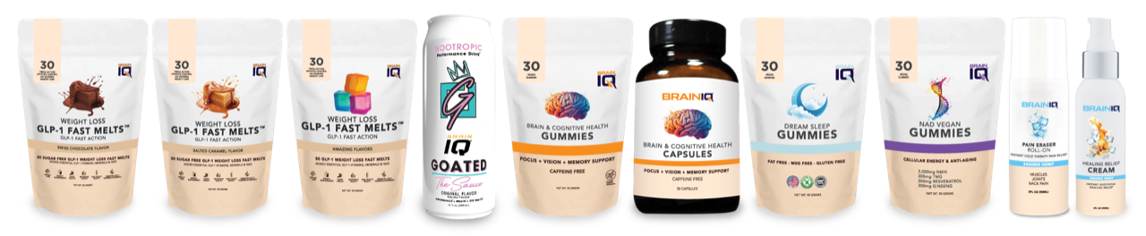
Hi [First Name],
I want to share something I’m really excited about with you. I recently partnered with BrainIQ Health, a company that provides science-backed, pharmaceutical-grade, drug-free solutions to support:
- Weight Loss & Weight Management
- Brain & Vision Health
- Pain & Inflammation Relief
- NAD Health & Beauty
- Restorative Sleep
What I love is that BrainIQ focuses on natural, effective solutions that make a real difference in everyday life.
As a thank-you for checking it out, you can get 5% off your first order with coupon code: YOUR COUPON CODE
YOUR AFFILIATE LINK
This is a wonderful way to begin (or continue) your wellness journey—with extra support and savings.
Wishing you health and happiness,
Affiliate/Clinic information

The products and the claims made about specific products on or through this document have not been evaluated by the United States Food and Drug Administration and are not approved to diagnose, treat, cure or prevent disease.

EMAIL 2: The Clinically Proven, GLP-1 Fast Melt Game Changer
Subject: This Fast Melt Chew Could Help You Lose 28.1 Pounds – Naturally and Faster than a Drug
Hi [First Name],
Weight loss should never come with scary side effects or prescription drugs.
That’s why our GLP-1 Fast Melt Sugar-Free Chews and Gummies are such a breakthrough. Inspired by the science behind GLP-1s (like Ozempic), our chews offer a drug-free alternative to:
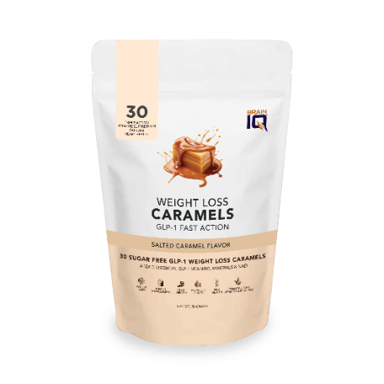
✔ Suppress appetite
✔ Support metabolic health
✔ Protect vision
✔ Improve blood sugar balance
✔ Lose 28.1 lbs in 10 weeks
✔ Lose up to 18.4% Body Fat
✔ Lose up to 4.5 Inches of Stomach Fat
Plus, fast melt chews taste amazing, are easy to take, and even buffer side effects for those already using GLP-1 meds.
Ready to help people lose weight and feel better naturally?
Experience the benefits of BrainIQ Health products with 5% off your first order! Use coupon code YOUR COUPON CODE HERE at checkout to enjoy this one-time discount. Don’t miss your chance to start your wellness journey with us!
YOUR AFFILIATE LINK TO THE WEIGHT LOSS FAST MELTS
Wishing you health and happiness,
Affiliate/Clinic information

The products and the claims made about specific products on or through this document have not been evaluated by the United States Food and Drug Administration and are not approved to diagnose, treat, cure or prevent disease.

EMAIL 3: Clinical Pain Relief with Zero Drugs
Subject: Clinical Pain Relief with Zero Drugs: A Safer Way to Ease Pain & Inflammation
Hi [First Name],
Pain doesn’t have to come with pills.
Our Drug-Free Pain & Inflammation Relief Roll-On and Cream Pump provides powerful relief using an all-natural topical formula. It works fast, absorbs deeply, and helps reduce inflammation and discomfort right at the source.
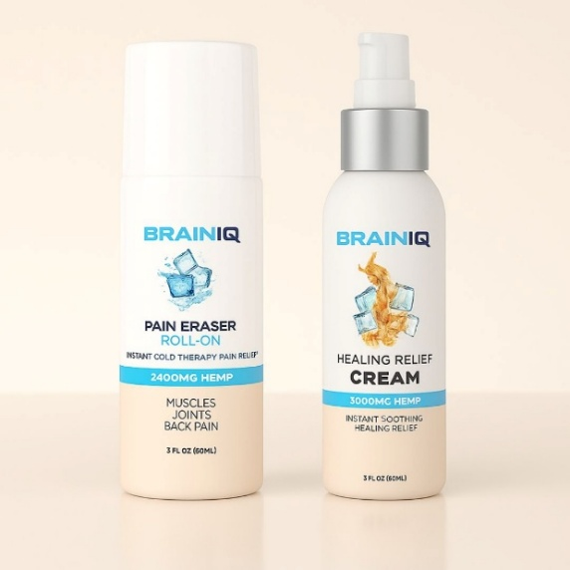
Whether you’re an athlete, busy parent, or health pro looking for safe solutions, this is a must-have.
- 3,000mg Organic Hemp
- Organic Coconut Oil
- Organic Aloe Vera Powder
- Organic Eucalyptus
- Organic Peppermint Oil
- Organic Arnica Montana Oil
- Organic Spearmint Oil
- Organic Lemongrass Oil
- Organic White Camphor Oil
- Organic Neem Oil
💡 Pro Tip: Great for chiropractors and PT clinics who want retail products that WORK.
Experience the benefits of BrainIQ Health products with 5% off your first order! Use coupon code YOUR COUPON CODE at checkout to enjoy this one-time discount. Don’t miss your chance to start your wellness journey with us!
YOUR AFFILIATE LINK TO THE PAIN RELIEF ROLL-ON AND HEALING RELIEF CREAM
Wishing you health and happiness,
Affiliate/clinic information
The products and the claims made about specific products on or through this document have not been evaluated by the United States Food and Drug Administration and are not approved to diagnose, treat, cure or prevent disease.

EMAIL 4: BrainIQ Natural, Brain & Vision Health
Subject: BrainIQ Brain & Vision Health-The Brain Drug that is not a Drug
Hi [First Name],
Increase Your Brain Performance and stop struggling with focus, memory, and mental fatigue.
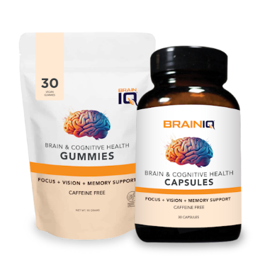
Our Cognitive Brain Health Capsules and Gummies are packed with over 40 neuro-nutrients that support clarity, mood, and cognitive performance – with zero stimulants or caffeine.
Clients report:
- Sharper memory
- Better concentration
- Mental calm + focus
If your patients or customers complain of brain fog, this is your go-to solution.
YOUR AFFILIATE LINK TO THE COGNITIVE BRAIN HEALTH CAPSULES AND GUMMIES
Wishing you health and happiness,
Affiliate/Clinic information

The products and the claims made about specific products on or through this document have not been evaluated by the United States Food and Drug Administration and are not approved to diagnose, treat, cure or prevent disease.

EMAIL 5: Tap Into Youthful Energy
Subject: Why NAD+ Sugar-Free, Vegan Gummies Are the Future of Longevity
Hi [First Name],
If you want to feel more energized, look younger, and function at your best, NAD+ is essential.
Our NAD Sugar-Free Vegan Gummies help support cellular repair, DNA protection, and healthy aging – all in a delicious, convenient form.
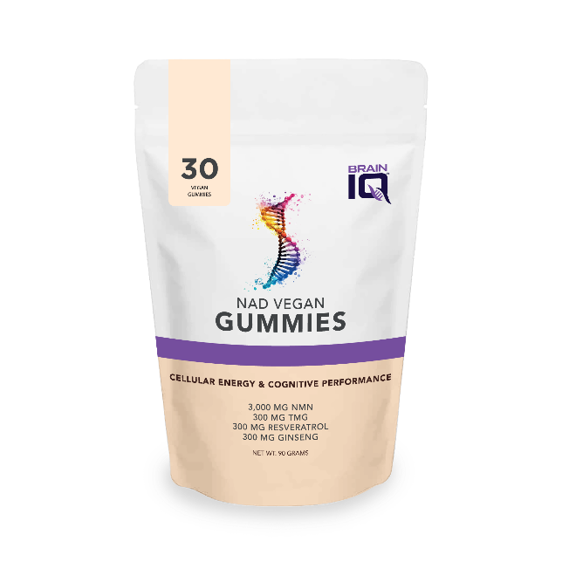
No sugar. No animal ingredients. Just clean, effective mitochondrial support.
- Boost Cellular Energy: Supports ATP production, providing sustainable energy throughout the day.
- Enhance Cognitive Performance: Helps improve mental clarity, focus, and memory retention.
- Support DNA Repair: Promotes healthy aging by supporting cellular repair processes.
- Combat Oxidative Stress: Helps protect cells from free radicals and environmental stressors.
- Longevity Pathways Activation: Encourages Sirtuin activation for optimal aging support.
- Full Absorption & Fast-Acting: Enjoy quick results with our delicious sour watermelon-flavored gummies.
Experience the benefits of BrainIQ Health products with 5% off your first order! Use coupon code YOUR COUPON CODE HERE at checkout to enjoy this one-time discount. Don’t miss your chance to start your wellness journey with us!
YOUR AFFILIATE LINK TO THE NAD GUMMIES
Energized for what’s next,
Wishing you health and happiness,
Affiliate/Clinic information

The products and the claims made about specific products on or through this document have not been evaluated by the United States Food and Drug Administration and are not approved to diagnose, treat, cure or prevent disease.

EMAIL 6: Sleep Like You Did Years Ago
Subject: Your Secret Weapon for Better Sleep (and Better Mornings)
Hi [First Name],
Good sleep is the foundation of good health.
Our Restorative Sleep Gummies are gentle, effective, and completely non-habit forming. They’re perfect for winding down, improving REM cycles, and waking up refreshed.
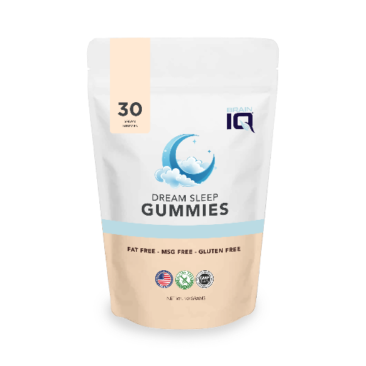
So many of our customers say: “This is the first sleep product that actually works.”
Ready to help others experience the same transformation?
Experience the benefits of BrainIQ Health products with 5% off your first order! Use coupon code YOUR COUPON CODE HERE at checkout to enjoy this one-time discount. Don’t miss your chance to start your wellness journey with us!
YOUR AFFILIATE LINK TO THE DREAM SLEEP GUMMIES
Wishing you health and happiness,
Affiliate/Clinic information

The products and the claims made about specific products on or through this document have not been evaluated by the United States Food and Drug Administration and are not approved to diagnose, treat, cure or prevent disease.

EMAIL 7: Are You In?
Subject: Join the Brain IQ Movement
Hi [First Name],
We’ve loved sharing BrainIQ Health’s top wellness products with you – and now, we’d love to officially invite you to join us.
Whether you want to become an affiliate, offer Brain IQ in your clinic, or be a wellness voice in your community, now is the time.
 Recurring income
Full training and support
Products people love (and reorder)
👉 Click to Join as a Brain IQ Partner Today YOUR AFFILIATE NETWORK LINK
👉 Wholesale Opportunities YOUR WHOLESALE AFFILIATE LINK
Are you interested in learning more? You can schedule a quick 15-minute call with one of BrainIQ Health’s team members:
- Rebecca White, BrainIQ Health’s National Partnership Director: https://calendly.com/contact-brainiqhealth/15min
- Zach, BrainIQ Health’s National Partnerships Associate: https://calendly.com/zach-brainiqhealth/15min
This is your chance to align with a brand that delivers real results — and helps you increase monthly sales while improving lives.
Wishing you health and happiness,
Affiliate/Clinic information

The products and the claims made about specific products on or through this document have not been evaluated by the United States Food and Drug Administration and are not approved to diagnose, treat, cure or prevent disease.

